**CYTVII-C-2D-4M-216-SET and CYTVII-C-2D-4M-216-CPU Manufacturing Test Procedure**

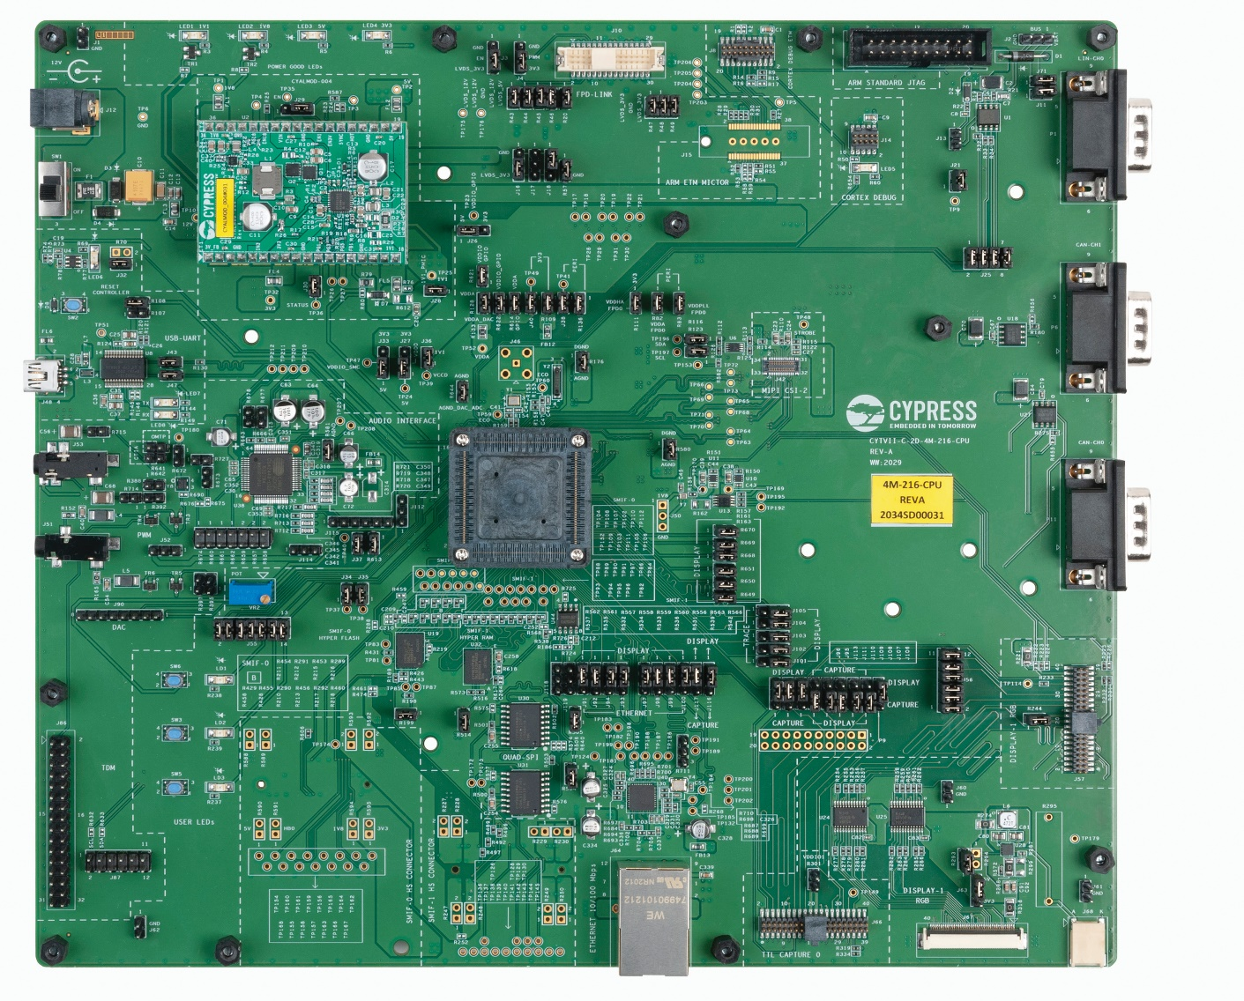

|  |
| --- |
| **Assembly number:** 121-60597-01 **Revision:** 14 |
| **Schematic number:** 600-60597-01 **Revision:**  1.0 |
| **Product:** CYTVII-C-2D-4M-216-CPU and CYTVII-C-2D-4M-216-SET |
| **Contact person:** Dharani Kumar (Dharani.Kumar-EE@infineon.com) |

Table of Contents

1 Test Summary: 4

1. Product Version(s) supported : 4

2. Total Test Coverage: 4

3. Test Time per Unit: 4

2 Documentation: 5

Documentation details 5

2.1 Delivery method for the documentation: 5

3 Equipment Requirements: 6

3.1 Hardware Requirements 6

PC/laptop requirements 7

3.2 Software Requirements 7

3.3 Firmware requirements 7

4 Download Default hex file: 8

5 Test Fixture Overview: 9

5.1 Graphical User Interface (GUI) Overview 9

5.2 General procedure for each test 10

6 Initial Set Up: 12

6.1 One time setup 12

6.2 Programming test-Jig 13

6.3 Initial jumper settings 13

7 Top Level Flow Chart: 15

7.1 Test procedure flowchart 15

8 Run the Test: 17

8.1 Power Supply test 17

8.1.1 Powering the test Setup 17

8.1.2 Device Lifecycle Conversion 18

8.2 Peripherals test (Firmware1 – Test Firmware): 20

8.2.1 User-LEDs test 21

8.2.2 User-Button test 22

8.2.3 Potentiometer test 23

8.2.4 Hyper-Flash test 24

8.2.5 Hyper-RAM test 25

8.2.6 TDM Sound Test 26

8.2.7 CANFD test 27

8.2.8 LIN test 28

8.2.9 Gigabit Ethernet Test 29

8.2.10 FPD Display Test 30

8.3 MIPI Camera test (Firmware2 – JTAG Firmware): 31

8.4 Shipping Firmware (Firmware3 – Shipping Firmware): 32

9 Sample report: 33

10 Default Switch / Jumper Position: 35

11 Special Instructions for Failed Units: 38

12 Additional Test Fixture Details (Appendix): 39

# Test Summary:

## Product Version(s) supported :

The product version supported is the CYTVII-C-2D-4M-216-SET and CYTVII-C-2D-4M-216-CPU board.

## Total Test Coverage:

The below table shows how many components are tested in this manufacturing test procedure.

|  |  |  |
| --- | --- | --- |
| **Total no. of**  **components** | **No. of components tested** | **Percentage**  **tested** |
| 660 | 618 | 93% |

## Test Time per Unit:

The test time per unit is 3 minutes.

# Documentation:

# Documentation details

**Documentation Details of CPU Board**

|  |  |  |  |
| --- | --- | --- | --- |
| **S.No** | **PCBA** | **Document** | **Arena Part #** |
| **1** | CYTVII-C-2D-4M-216-CPU | CYTVII-C-2D-4M-216-CPU BOARD PCB LAYOUT | 600-60597-01 |
| **2** | CYTVII-C-2D-4M-216-CPU BOARD FABRICATION DRAWING | 610-60597-01 |
| **3** | CYTVII-C-2D-4M-216-CPU BOARD ASSEMBLY DRAWING | 620-60597-01 |
| **4** | CYTVII-C-2D-4M-216-CPU BOARD SCHEMATIC DRAWING | 630-60597-01 |

**Documentation Details of PMIC Board**

|  |  |  |  |
| --- | --- | --- | --- |
| **S.No** | **PCBA** | **Document** | **Arena Part #** |
| **1** | CYTVII-C-2D-4M-PMIC | CYTVII-C-2D-4M-216-CPU-PMIC BOARD PCB LAYOUT | 600-60584-01 |
| **2** | CYTVII-C-2D-4M-216-CPU-PMIC BOARD FABRICATION DRAWING | 610-60584-01 |
| **3** | CYTVII-C-2D-4M-216-CPU PMIC BOARD ASSEMBLY DRAWING | 620-60584-01 |
| **4** | CYTVII-C-2D-4M-216-CPU PMIC BOARD SCHEMATIC DRAWING | 630-60584-01 |

# 2.1 Delivery method for the documentation:

The delivery method is ARENA PLM System.

# Equipment Requirements:

## Hardware Requirements

|  |  |  |  |
| --- | --- | --- | --- |
| **S no.** | **Equipment** | **Quantity** | **Supplied by** |
| 1 | 12V Power Adapter | 1 | Infineon |
| 2 | MiniProg4 programmer with USB-C-Type cable | 1 | Infineon |
| 3 | USB Mini-B cable | 1 | Infineon |
| 4 | Basic Digital Multimeter | 1 | Infineon |
| 5 | Female to Male Jumper | 1 | Infineon |
| 6 | Female to Female DB 9 Cable | 1 | Infineon |
| 7 | Earphone | 1 | Infineon |
| 8 | Ethernet & LIN test Jig | 1 | Infineon |
| 9 | Arm JTAG 20 pin connector and 10 pin connectors | 1 | Infineon |
| 10 | RJ45 Cable | 1 | Infineon |
| 11 | LVDS Display | 1 | Infineon |

## PC/laptop requirements

The below are the minimum requirements for the PC/Laptop used for testing.

|  |  |  |
| --- | --- | --- |
| **S no.** | **Specification** | **Requirement** |
| 1 | Processor | 2 GHz or higher |
| 2 | RAM | 2 GB or higher |
| 3 | Operating system | Win 7/ Win 10/ Win 11 |
| 4 | Hard drive free space | 1 GB or more |
| 5 | USB port | USB3.0 and USB2.0 |

## Software Requirements

|  |  |  |  |
| --- | --- | --- | --- |
| **S no.** | **Software** | **Arena part #** | **Gitlab link** |
| 1 | SW.zip | 150-60342-01 | [KIT_T2G_C-2D-4M_LITE MTP SW](https://gitlab.intra.infineon.com/atv_mc_mtp/traveo_kits/cytvii-c-2d-devices/cytvii-c-2d-4m-216-cpu_set/-/tree/main/Source_2025/MTP_HEX?ref_type=heads) |

## Firmware requirements

|  |  |  |  |
| --- | --- | --- | --- |
| **S no.** | **Software** | **Arena part #** | **Gitlab link** |
| 1 | FW.zip | 101-60456-01 | [KIT_T2G_C-2D-4M_LITE MTP FW](https://gitlab.intra.infineon.com/atv_mc_mtp/traveo_kits/cytvii-c-2d-devices/cytvii-c-2d-4m-216-cpu_set/-/tree/main/Source_2025/MTP_HEX?ref_type=heads) |

1. For each new build make sure that the latest software and firmware is downloaded from Arena before starting the testing.
2. For the software and firmware files downloaded from arena, verify that the checksum for the file is matching to the arena checksum.

# Download Default hex file:

Download the Hex files from the link mentioned above in section 3.4 and 3.5. Programming the hex files is mentioned in the section 8.2.

# Test Fixture Overview:

## Graphical User Interface (GUI) Overview

Connect the Type-B Mini USB cable at J48 (Refer to Figure 5), on the CPU board under test (DUT). Connect the other end of the cable to a PC and then open the GUI. The Graphical User Interface gives an interactive way to perform the test. Each part of the GUI is explained below.

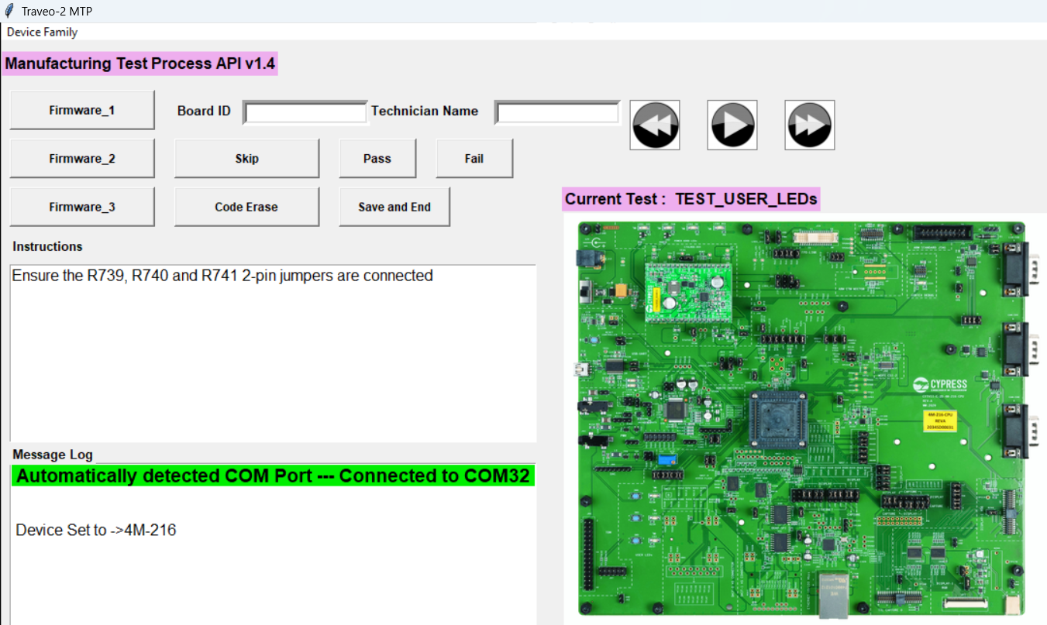

Start

Next

Previous

Image Window

Instruction Logs

Message Logs

***Figure 1: MTP GUI Overview***

**Instructions Log Window:**

It shows the instructions to perform each test. Please refer to these instructions before starting a test.

**Message Log Window:**

This displays messages about the status of the on-going test. Please refer to these messages while doing a test.

**Image window:**

The title of the Image window displays the current test. This window displays the image of the board, in which the particular item(s) under test is highlighted.

**Buttons:**

Next button : Click this to move to the next test.

Previous button : Click this to move to the previous test.

Start Button : Click this button to start a test.

Skip Button : Click this to skip a test.

Pass Button : Click this if a test is passed.

Fail Button : Click this if a test is failed.

## General procedure for each test

1. Navigate to the test using the Next/Previous buttons.
2. Follow the instructions shown in the Instruction Window to perform the test.
3. Refer to the Image Window to find the item under test. Make the connections as shown in Image window.
4. Press the Start button to start the test or Next button to skip it.
5. If a test is skipped, it will be marked as failed.
6. Once the start button is pressed, the test must be completed before moving to next test.
7. Message Log Window will display the status of the current test.
8. Press the PASS/FAIL after each test result shown in Message Window.
9. Some of the tests will have pre-defined time period within which the test has to be completed.
10. A warning message will be displayed in the Message log if half the time period is over (highlighted below).

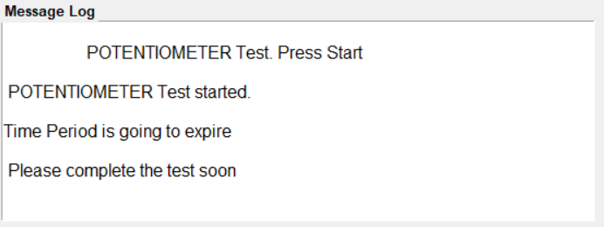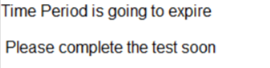

***Figure 2: Test time expiration warning message***

1. If the test is not passed within this time period, it will be automatically marked as failed.
2. Once the last test is over, enter the Board number and Technician name in the respective boxes and then click “Save and End” button. Test reports will be saved in the “Test_Reports” folder created before.

# Initial Set Up:

## One time setup

* Download files FW.zip and SW.zip from the arena. Unzip both the files at a known location.
* Please install the software: TVII_MTP-1.4 found inside the SW folder (ignore if already done).
* Please install Auto Flash Utility 1.3.0 found inside SW folder (ignore if already done).
* Create a new folder in C drive and name it as “MTP_SREC_FILES” (ignore if already done).
* Create a new folder “TVII-C-2D-4M” inside the “MTP_SREC_FILES” folder (if already present ignore this step).
* Copy the folder “4M-216” from the folder FW and paste it inside the folder “TVII-C-2D-4M”.
* 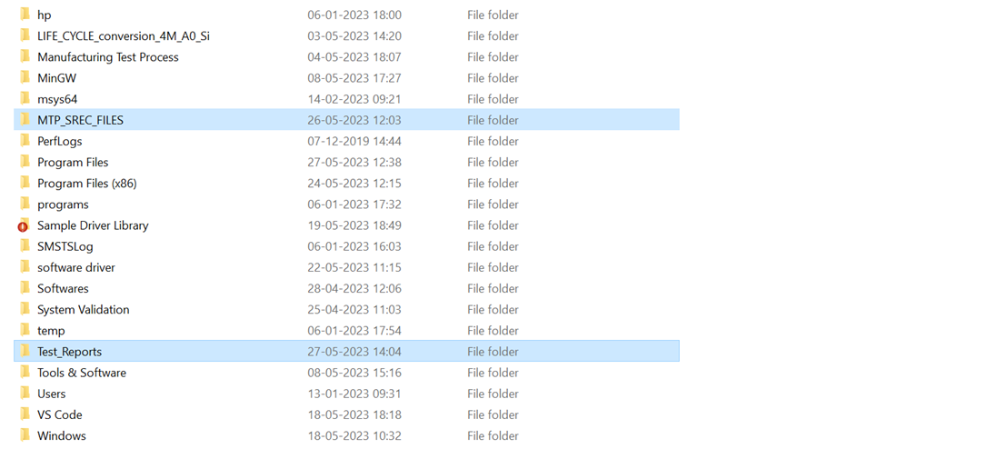Create a new folder “Test_Reports” inside the C drive (ignore if already done).

***Figure 3: folders to be created inside C drive***

* Copy the “MTP_Py_Config.txt” file from the FW folder and paste it in location C:\Program Files \TVII_MTP folder.
* If it asks for administrative access, click continue.
* Copy the “LIFE_CYCLE_conversion_4M_A0_Si” folder from the FW folder and then paste it to “C:\”

## Programming test-Jig

1. Connect Miniprog4 10 pin cable to Cortex Debug (J14) on Test-Jig.

2. Do the Initial Jumper Settings (section - 6.3), then remove the R735, R736, R737, R738, R739, R741.

3. Connect the jumpers R740, R742, R743, R744, R745.

4. Connect the jumpers J91(2-3), J92(2-3), J93(2-3), J94(2-3), J97(2-3), J98(2-3), J99(2-3), J100(2-3), R711(2-3).

5. Connect the 12V power adapter at J12 on the Test-Jig board and then power on.

6. Go to inside “C:\MTP_SREC_FILES\TVII-C-2D-4M\4M-216\TestJig\ “ directory.

7. You will find one TestJig_Firmware.bat file, double click on that.

8. It will take some time to flash. If flash is completed then you can see “LD2” is blinking on the Test-Jig board.

9. Disconnect the Miniprog4 and now the Test-Jig board is ready for the testing

## Initial jumper settings

Make sure the following Mini jumpers are installed before starting the test.

| **Jumper# on Board to test** | **Position** |
| --- | --- |
| J29 | 1-2 |
| J30 | 1-2 |
| J28 | 1-2 |
| J21 | 1-2 |
| J27 | 1-2 |
| J38 | 1-2 |
| J36 | 1-2 |
| J37 | 1-2 |
| J33 | 1-2 |
| J26 | 1-2 |
| J34 | 1-2 |
| J40 | 1-2 |
| J35 | 1-2 |
| R136 | 1-2 |
| R614 | 1-2 |
| R613 | 1-2 |
| R83 | 1-2 |
| R82 | 1-2 |
| R111 | 1-2 |
| R621 | 1-2 |
| R622 | 1-2 |
| R109 | 1-2 |
| R128 | 1-2 |
| R644 | 1-2 |
| R580 | 1-2 |
| R176 | 1-2 |
| R581 | 1-2 |
| J32 | 1-2 |
| J43 | 1-2 |
| J47 | 1-2 |
| R108 | 1-2 |
| J3 | 2-3 |
| J4 | 2-3 |
| J18 | 1-2 |
| R43 | 1-2 |
| R44 | 1-2 |
| R49 | 1-2 |
| R46 | 1-2 |
| R20 | 1-2 |
| R57 | 1-2 |
| R47 | 1-2 |
| R48 | 1-2 |
| R45 | 1-2 |
| J16 | 2-3 |
| J11 | 1-2 |
| J71 | 1-2 |
| J112 | 1-2 |
| R123 | 1-2 |
| R116 | 1-2 |
| J114 | 2-3 |
| R293 | 1-2 |
| J63 | 1-2 |
| R714 | 1-2 |
| R715 | 1-2 |

# Top Level Flow Chart:

## Test procedure flowchart

Get the CYTVII-C-2D-4M-216-CPU Board

Connect the default jumpers (section 6.2)

Perform power supply test (section 8.1)

Do the Lifecycle Conversion

Connect the kit to the PC and start the MTP tool

Flash the test firmware **Firmware_1**

Perform all the individual tests

Flash MIPI camera test firmware **Firmware_2**

Flash the shipping firmware **Firmware_3**

After flashing shipping firmware, save the test report

# Run the Test:

## Power Supply test

### Powering the test Setup

1. Before power up the DUT board, connect the MIPI Camera to J42 connector (figure - 28).
   1. Connect the 12V power adapter at J12 on the CPU board under test (DUT) and the other end to the mains supply. Refer to Figure 4

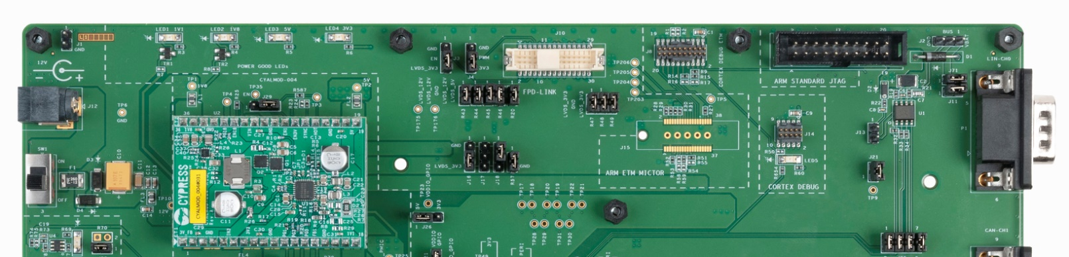

***Figure 4: Power Supply Connector J12 on CPU Board under Test***

* 1. Turn on the switch SW1 on the CPU board. The power LED1, LED2, LED3 and LED4 turns ON indicating the 1.1V, 1.8V, 3.3V and 5V is getting generated. Refer to Figure 4
  2. Connect the Type-B Mini USB cable at J48, on the CPU board under test (DUT). Connect the other end of the cable to a PC. Refer to Figure 5

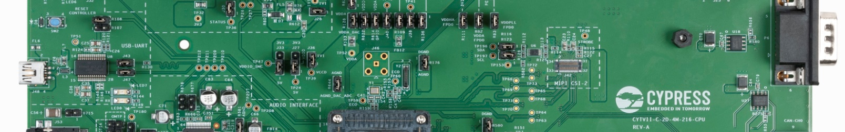

***Figure 5: USB Connector J48 on CPU Board under Test***

* 1. Once the board is powered ON check for the below LED indications.

|  |  |  |
| --- | --- | --- |
| **Sl. No** | **LED on Board under test** | **Status** |
| 1 | LED4 | ON |
| 2 | LED3 | ON |
| 3 | LED2 | ON |
| 4 | LED1 | ON |

* 1. Measure the voltage between the following points.

|  |  |  |
| --- | --- | --- |
| **Sl. No** | **Measurement on test point** | **Expected Voltage** |
| 1 | TP10 and TP6 (GND) | 12.0V +/-10% |
| 2 | TP2 and TP6 (GND) | 5.0V +/-10% |
| 3 | TP32 and TP6 (GND) | 3.3V +/-10% |
| 4 | TP1 and TP6 (GND) | 1.8V +/-10% |
| 5 | TP25 and TP6 (GND) | 1.1V +/-10% |
| 8 | TP38 and TP6 (GND) | 1.8V +/-10% |
| 9 | TP169 and TP6 (GND) | 1.5V +/-10% |
| 10 | TP170 and TP6 (GND) | 2.8V +/-10% |

### Device Lifecycle Conversion

1. Connect MiniProg4 10-Pin cable to J14 on DUT
2. Go to, C:/ LIFE_CYCLE_conversion_4M_A0_Si/scripts folder
3. Click the “VirginToNormalProvisioned.bat” which is in the scripts folder.
4. Wait for some time and after the end of Lifecycle conversion.
5. Once the terminal closes, open “scripts/4M_Silicon/ R01_SortToNormalP” folder.
6. Open 8_BasicTest.txt file.
7. Go to the end of the file and check whether “****Part is in NORMAL Protection State****” is there or not.

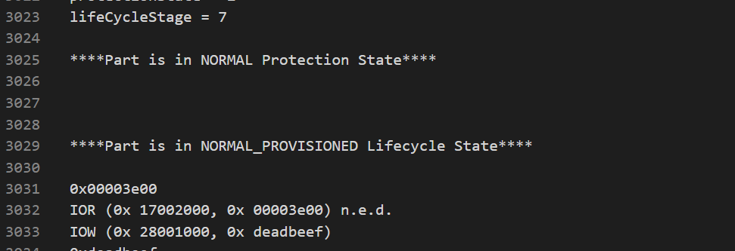

**Figure 6: Lifecycle conversion output**

## Peripherals test (Firmware1 – Test Firmware):

Follow the below instructions –

1. Connect the Miniprog4 using the 10-Pin cable to Cortex Debug (J14), and turn on the board.
2. Connect the Type-B Mini USB cable at J48 (Refer to Figure 5), on the CPU board under test (DUT).
3. Open the MTP application from C:\Program Files\TVII_MTP\MTP_GUI.
4. Go to Device Family -> CYTVII-C-2D-4M -> 4M-216, mentioned in Figure 7.

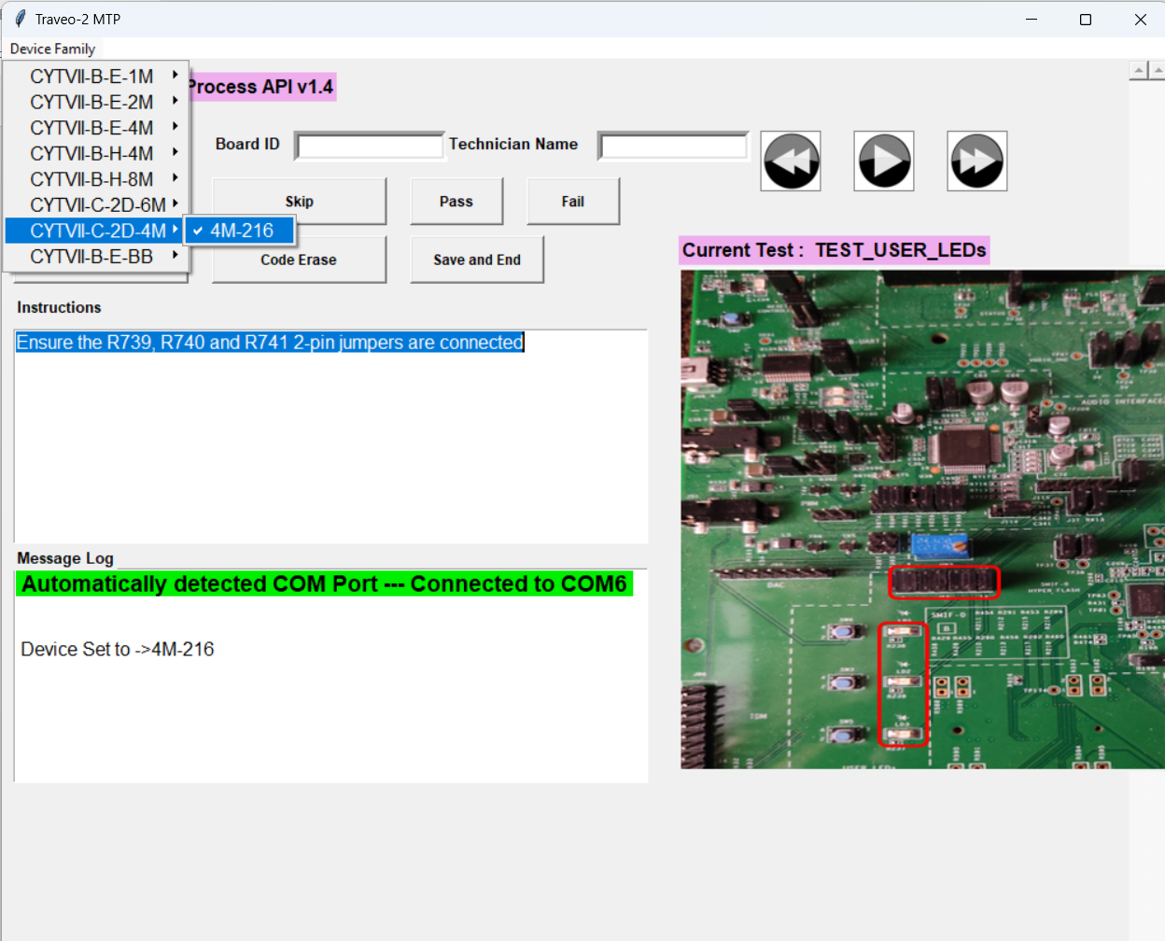

***Figure 7: Selecting TVII-C-2D-4M-216-CPU***

1. Press the Firmware1 button, it will take some time to flush the code.
2. After flushing the code, do the all peripheral testes.
3. Read the instructions from the Instruction log window on the GUI and do the necessary changes on the board before starting the test.

### User-LEDs test

1. Ensure the R735, R736, R737, R738, R739, R740 and R741 jumpers are connected (figure – 8).
2. Press the start button in the MTP GUI to start the User-LED test.
3. Press the “Pass” button if the LD1, LD2 and LD3 are blinking, otherwise press “Fail” button.

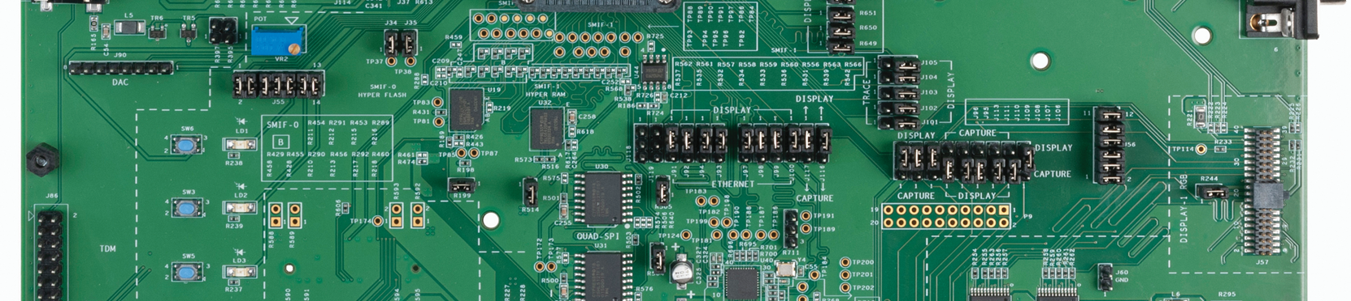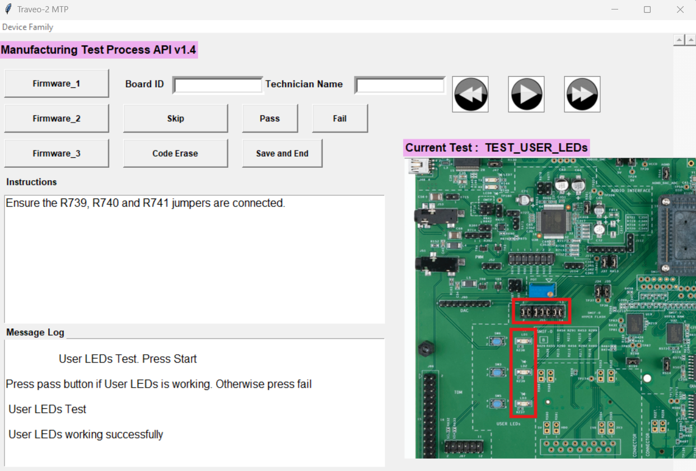

***Figure 9: User LED Output Message***

***Figure 8: User LED Test***

### User-Button test

1. Click on the next button to proceed to User-Button test and click on the play button to start the test.
2. After that press the SW5, SW3, SW6 one by one.
3. After pressing the three user button one by one, you will see the below success message (figure - 11).

***Figure 11: User Button Output Message***

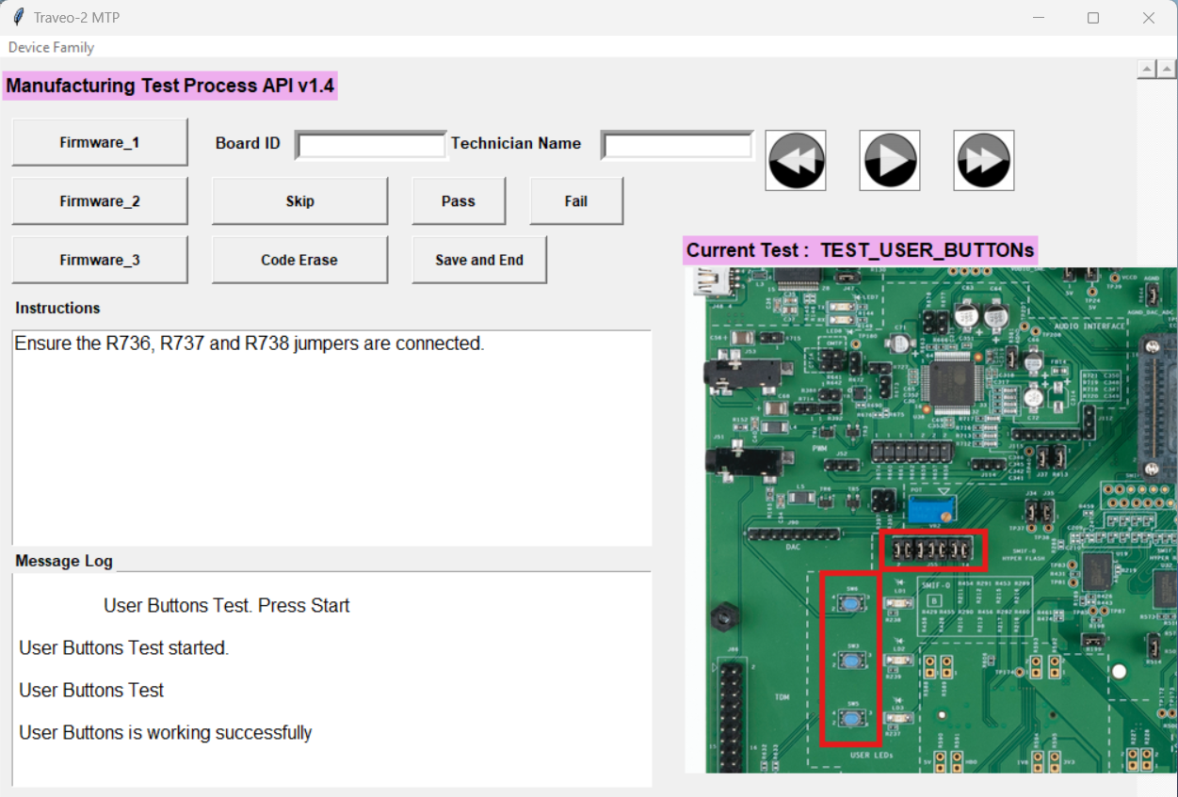

***Figure 10: User Button Test***



### Potentiometer test

* + - 1. Keep the potentiometer nob in one of it’s end (it could be left side or right side).
      2. Click on the next button to proceed to next test and click on the play button to start the test.
      3. After starting the test rotate the potentiometer nob towards the other end.
      4. After a certain time you will see the below success message (figure – 13).

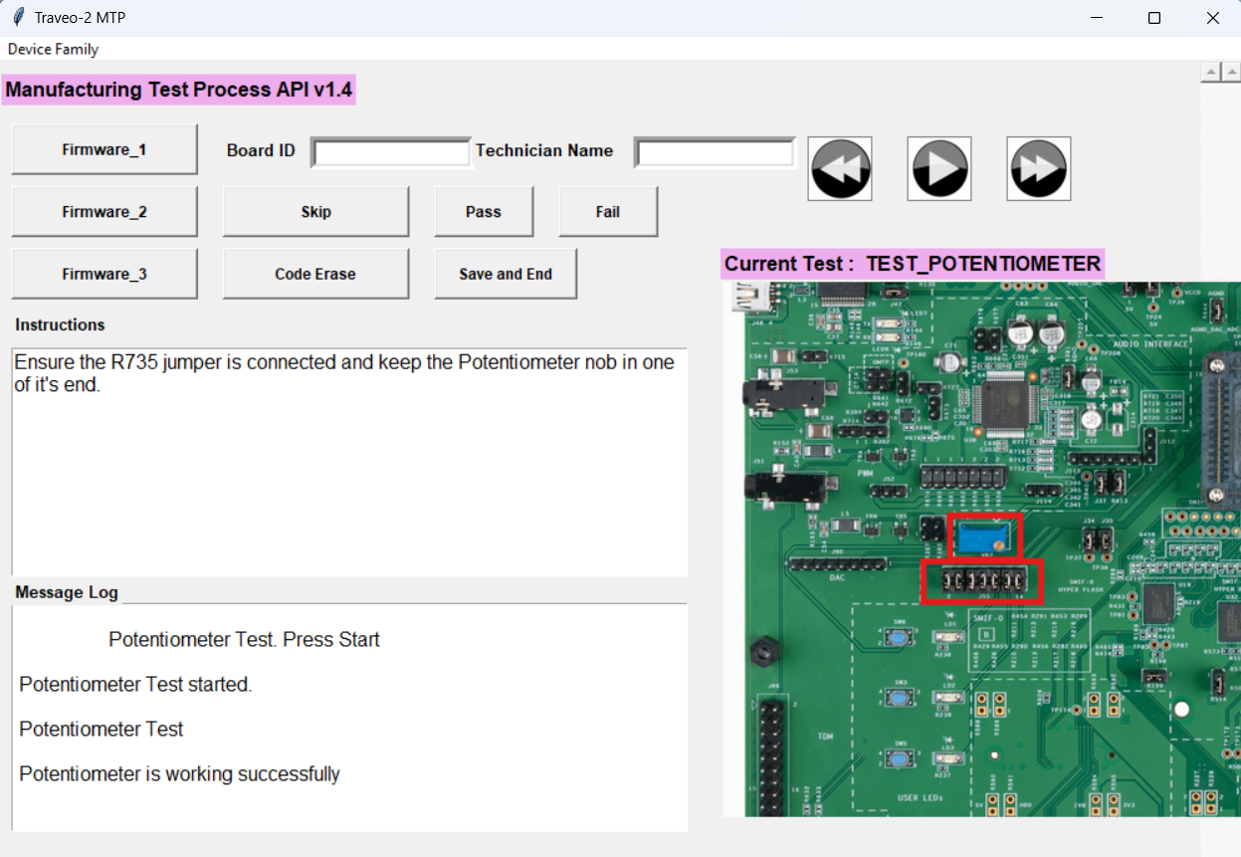

***Figure 13: Potentiometer Test Output Message***

***Figure 12: Potentiometer Test***



### Hyper-Flash test

Ensure the jumper R119 is connected.

Click on the next button to proceed to next test and click on the play button to start the test.

After 2-3 second by starting the test you will find the below success message (figure – 15).

***Figure 15: Hyper-Flash Output Message***

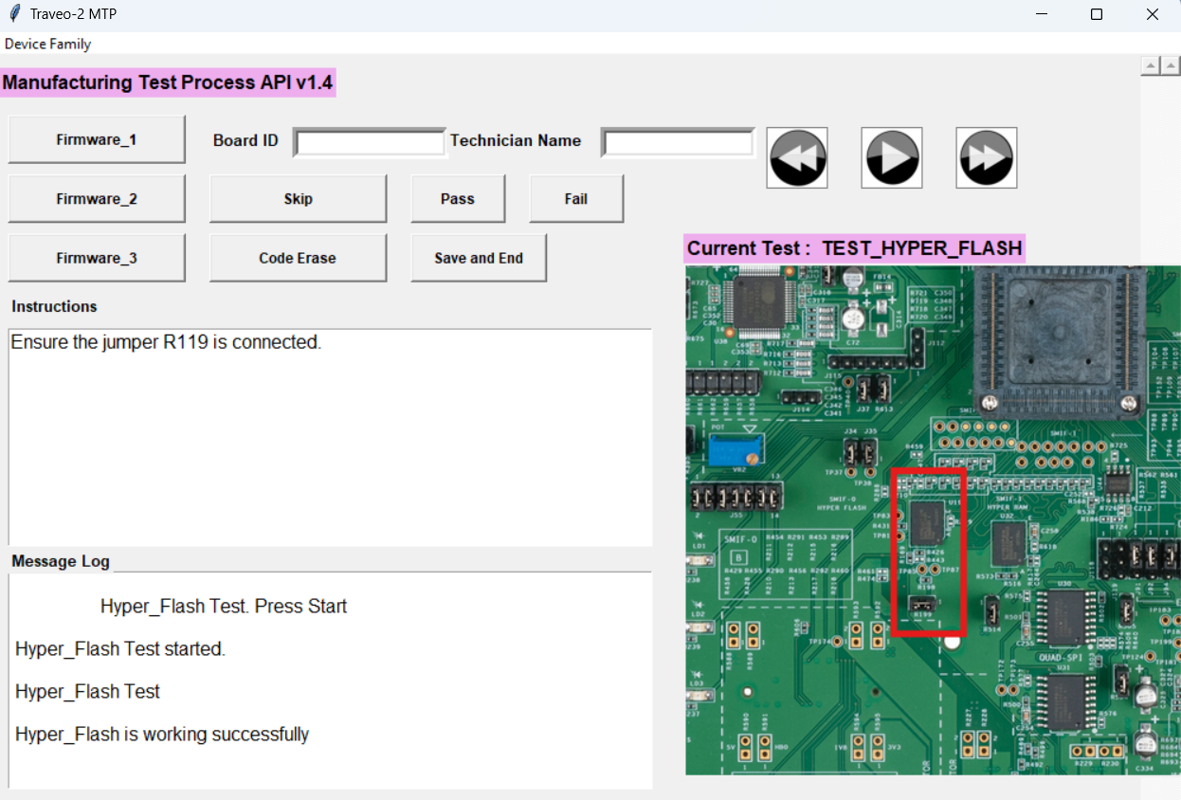

***Figure 14: Hyper-Flash Test***

### Hyper-RAM test

1. Remove the jumpers R504 and R505 and ensure the jumper R514 is connected.
2. Click on the next button to proceed to next test and click on the play button to start the test.
3. After 2-3 second by starting the test you will find the below message (figure – 17).

***Figure 16: Hyper-RAM Test***

***Figure 17: Hyper-RAM Output Message***

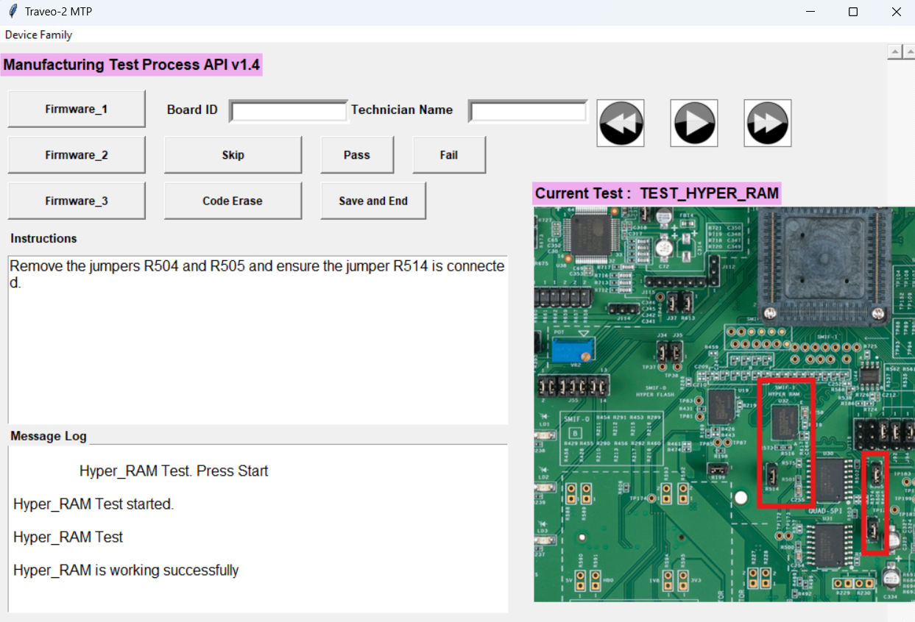

### TDM Sound Test

1. Connect the Jumpers (R641-1 + R642-2) and (R641-2 + R642-1) if you are using CTIA headphones (Android mobile Headphones). For CY Provided Headphone, connect R641(1-2) and R642(1-2). Also insert R662, R660, R661, R659, R657, R658, R672, R677, R678.
2. Connect the headphones to the 3.5mm headphone jack (J53).
3. Click on the next button and click on the play button to start the TDM test.
4. Once you hear continuous beep sound then press “Pass” button on the GUI otherwise press “Fail” button.

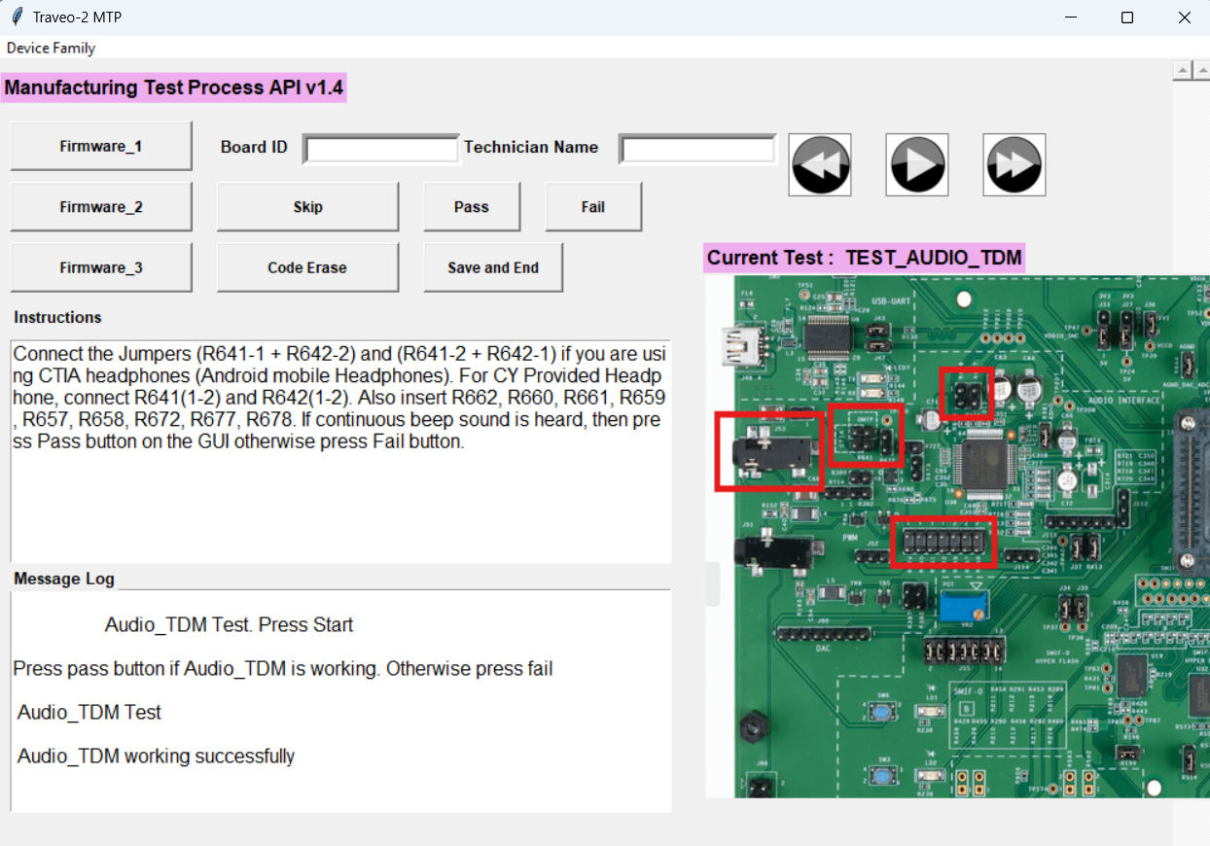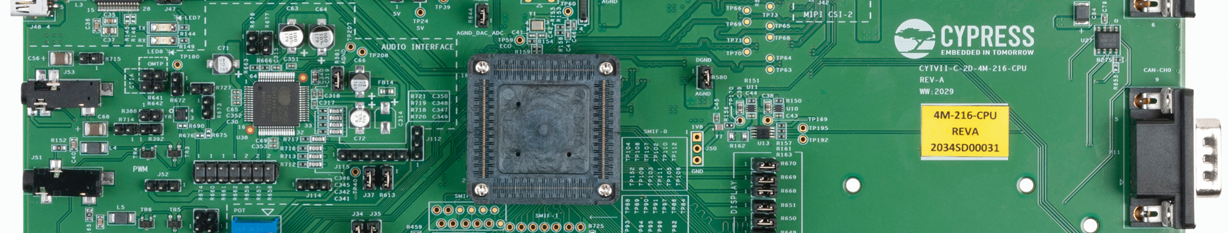

***Figure 19: TDM Sound Output Message***

***Figure 18: TDM Sound Test***

### CANFD test

1. Insert R751, R750, R749, R748, R747, R746 jumpers.
2. Now Connect the DB9 cable between the CAN0 (P11) and CAN1 (P6) channel.
3. Click the next button to proceed to CAN test and click on the play button on the GUI to start the test.
4. Then the data will be transferred between CAN0 and CAN1 channel and then the message log will be displayed as shown in the Figure - 21

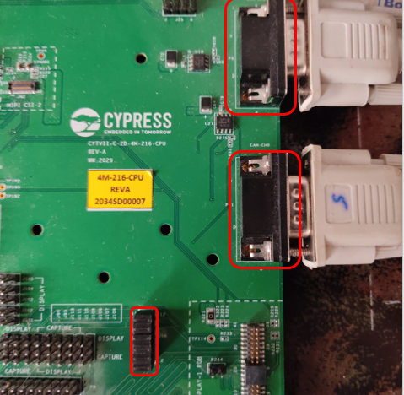

***Figure 20: CANFD Test***

***Figure 21: CANFD Output Message***

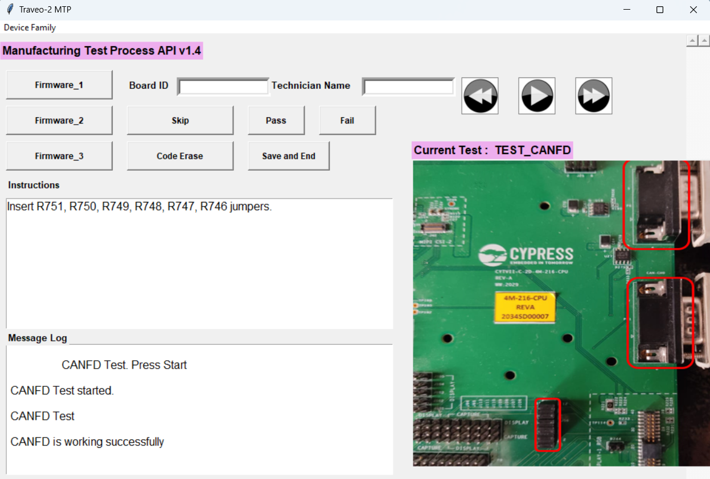

### LIN test

1. Remove the jumpers R735, R736, R737, R738, R739, R740, R741 and Insert R742, R743, R744, R745.
2. Connect LIN-0 (P1) on DUT and LIN-0 (P1) on test jig board with the DB9 female cable.
3. Press the Reset Button (SW2) on the Test-Jig board.
4. Click on the next button to proceed to the LIN test and click on play button to start the LIN test.
5. Data is transferred between the LIN0(DUT) and LIN0(Test Jig) and message is displayed on the message log as shown in the Figure-23

***Figure 23: LIN Output Message***

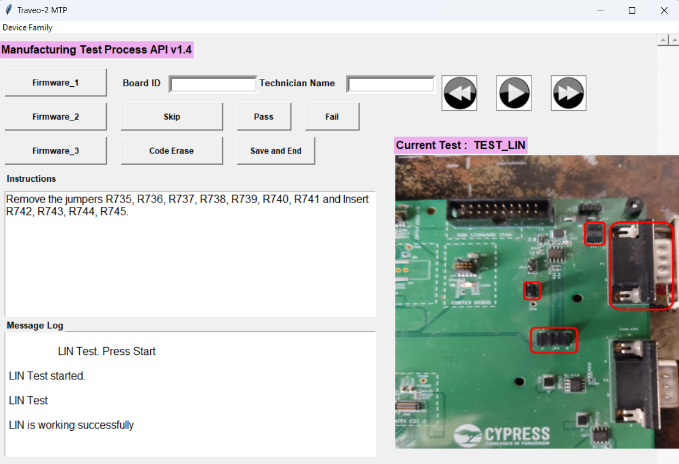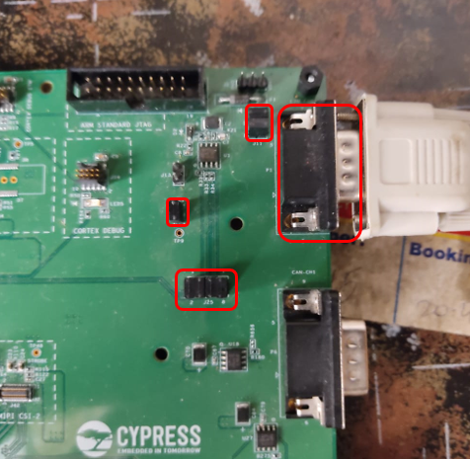

***Figure 22: LIN Test***

### Gigabit Ethernet Test

1. Connect the jumpers J91(2-3), J92(2-3), J93(2-3), J94(2-3), J97(2-3), J98(2-3), J99(2-3), J100(2-3), R711(2-3).
2. Connect RJ45 cable to J64 on DUT and connect other end of RJ45 to Test-Jig.
3. Click the next button and start the test by pressing the play button on the GUI tool.
4. Once the ethernet data frame is received successfully a success message will be shown on the message log window as per Figure-25
5. 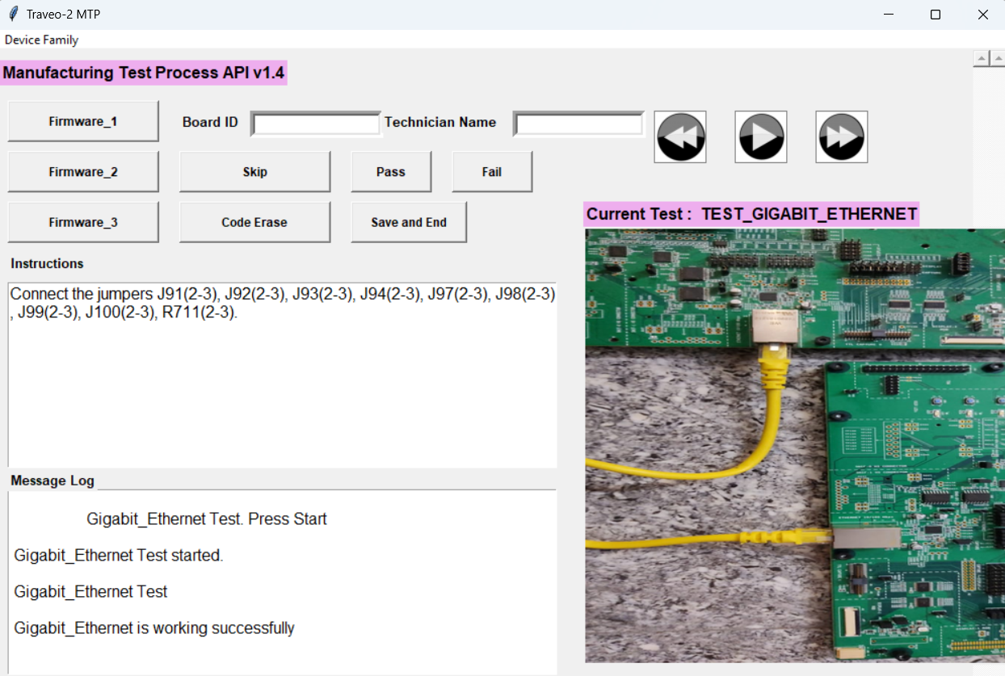Disconnect the Test-Jig board from the DUT board.

***Figure 24: Gigabit Ethernet Test***

***Figure 25: Gigabit Ethernet Output Message***

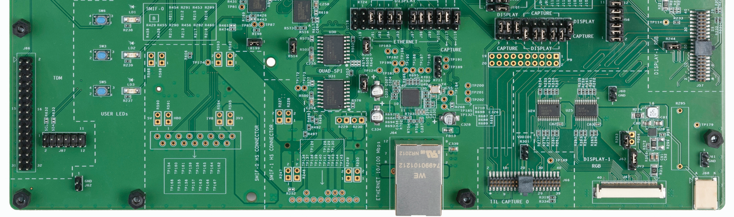

## 8.2.10 FPD Display Test

1. Remove R742, R743, R744, R745 and insert R735, R736, R737, R738, R739, R740, R741. All the jumpers and FPD Display are connected by default.
2. Connect the FPD display into the J10 connector (figure – 26)
3. Click on the next button to proceed to the FPD test and click on play button to start the FPD test.
4. Press “PASS” button if you see the IRIS patter on the FPD display, otherwise press “FAIL” button.

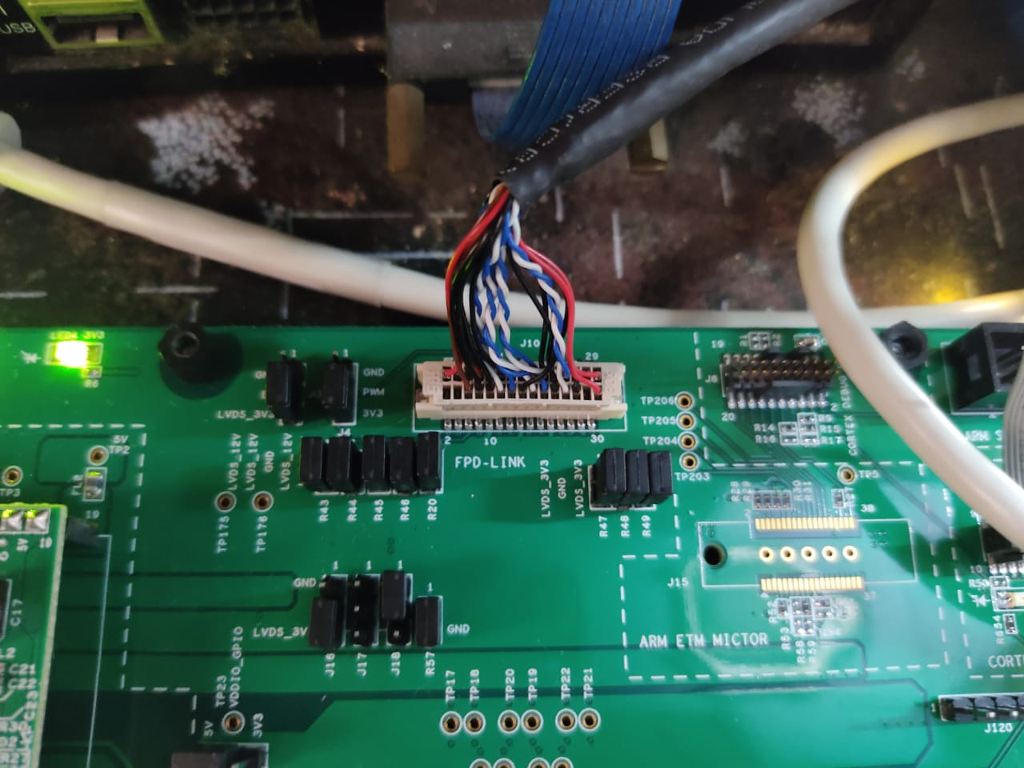

***Figure 26: FPD Display Test***

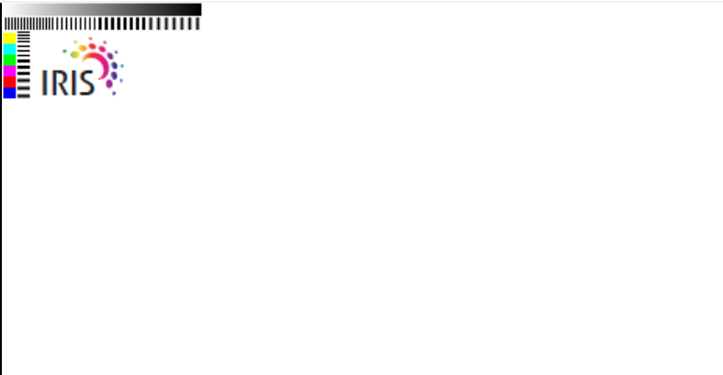

***Figure 27: FPD Display Output***

## MIPI Camera test (Firmware2 – JTAG Firmware):

1. Connect the Miniprog4 using the 20-Pin cable to CORTEX DEBUG ETM (J8) on the DUT board.
2. Connect the jumpers R736, R737, R739, R740 and R741.
3. Click on the “Firmware2” button on the GUI.
4. After successful flashing, you will see the image on the FPD display which was captured by the MIPI camera. Also you will see the LD1, LD2 and LD3 are toggling in a particular pattern.
5. Press the “SW3” button if image is showing on the FPD display. If image is not showing then press the “SW6” button.

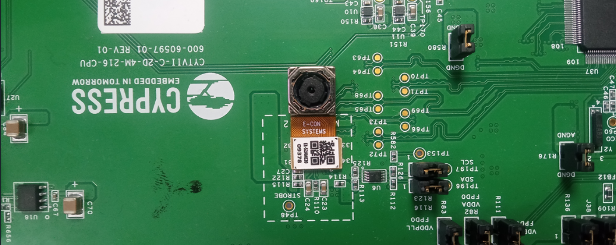

***Figure 28: MIPI Camera Test***

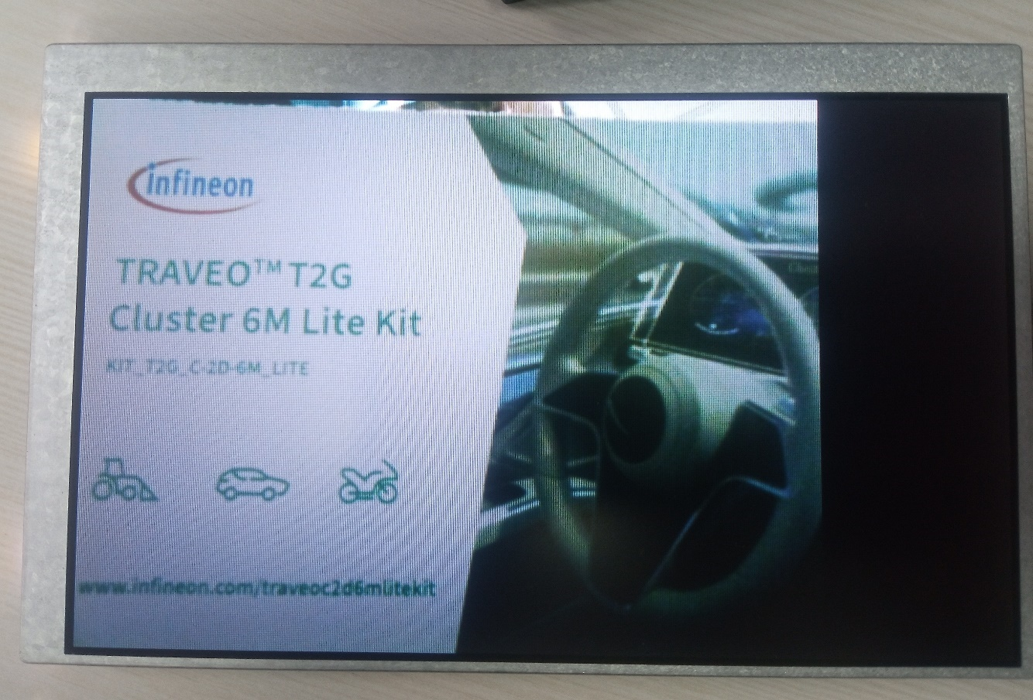

***Figure 29: MIPI Camera Output***

## Shipping Firmware (Firmware3 – Shipping Firmware):

1. Connect the Miniprog4 using the 20-Pin cable to ARM STANDARD JTAG (J7) on the DUT board.
2. Ensure the R735, R736, R737, R738, R739, R740 and R741 jumpers are connected
3. Click the “Firmware3” button on GUI.
4. After successful flashing remove the miniprog-4 connected to the DUT board.
5. You will see the image on the FPD display which was captured by the MIPI camera. Also you will see the LD1, LD2 and LD3 are toggling in a particular pattern, this indicates the Shipping Firmware pass status.
6. Enter the Board ID and name of the technician in the Board ID and Technician Name filed respectively.

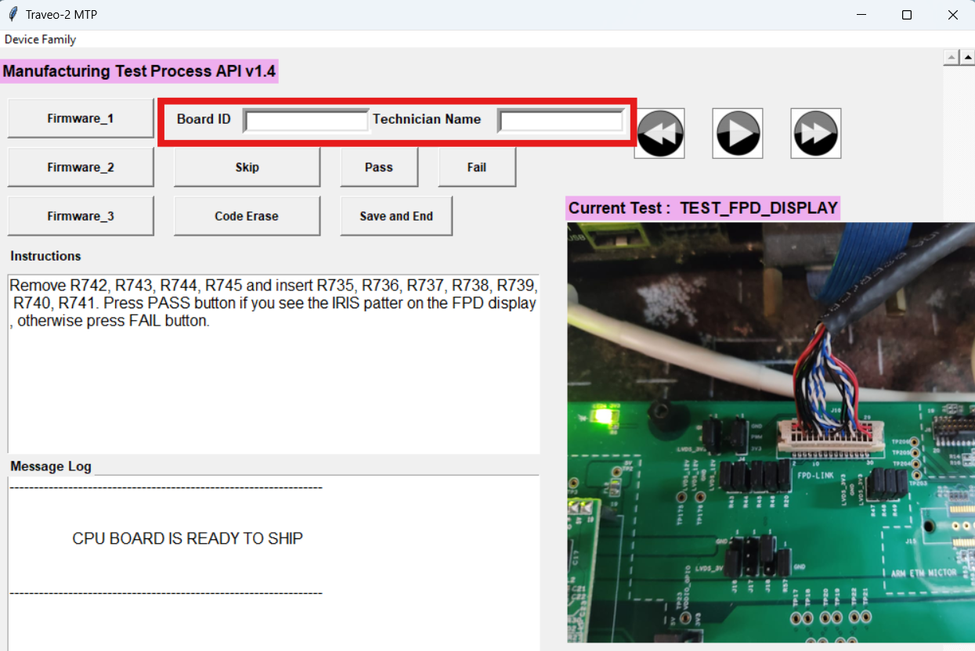

***Figure 30: Board ID and Technician Name***

1. Now click the “Save and End” button on GUI.
2. Close the GUI.
3. Now remove the Display, cable, power adapter.
4. Now the Board is ready for shipping.
5. The tested board to be shipped with power adapter and USB mini-B cable with which the board was tested.

# Sample report:

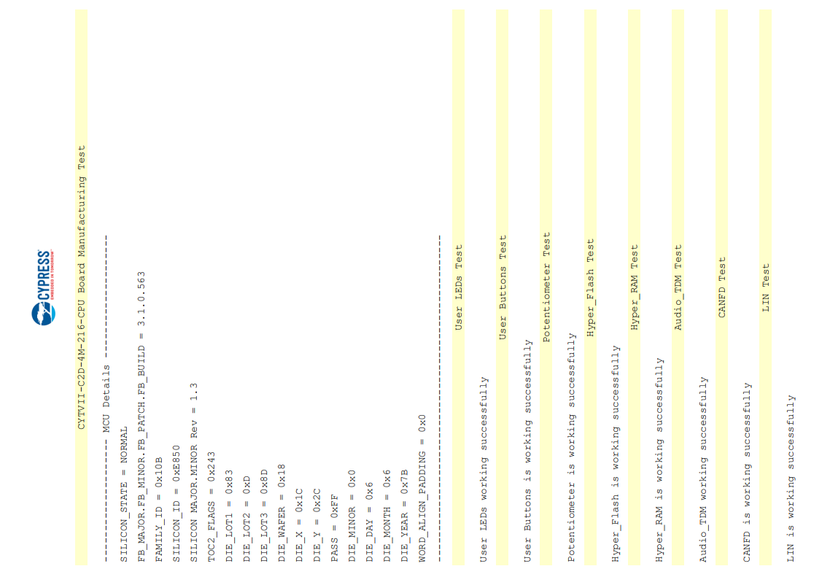

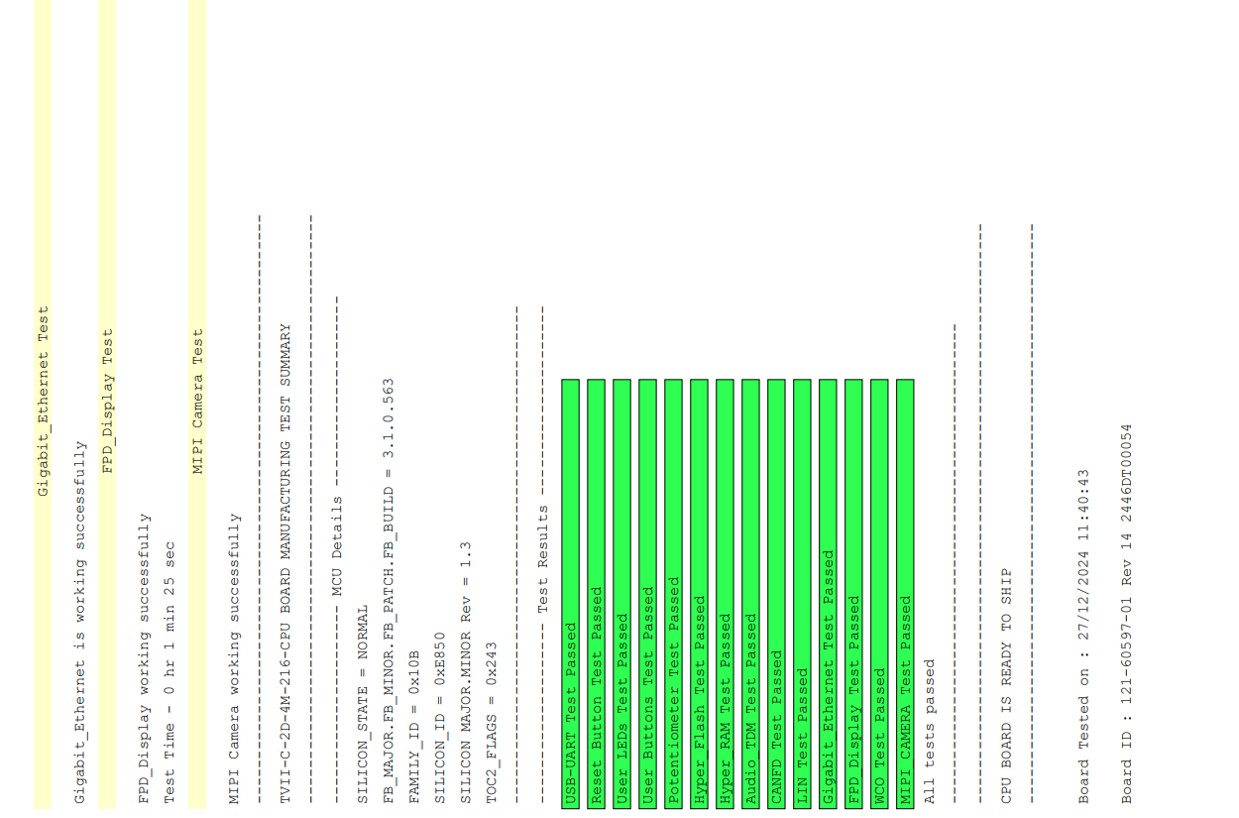

# Default Switch / Jumper Position:

| **Jumper# on CPU Board** | **Position** |
| --- | --- |
| J29 | 1-2 |
| J30 | 1-2 |
| J28 | 1-2 |
| J21 | 1-2 |
| J27 | 1-2 |
| J38 | 1-2 |
| J36 | 1-2 |
| J37 | 1-2 |
| J33 | 1-2 |
| J26 | 1-2 |
| J34 | 1-2 |
| J40 | 1-2 |
| J35 | 1-2 |
| R136 | 1-2 |
| R614 | 1-2 |
| R613 | 1-2 |
| R83 | 1-2 |
| R82 | 1-2 |
| R111 | 1-2 |
| R621 | 1-2 |
| R622 | 1-2 |
| R109 | 1-2 |
| R128 | 1-2 |
| R644 | 1-2 |
| R580 | 1-2 |
| R176 | 1-2 |
| R581 | 1-2 |
| J32 | 1-2 |
| J43 | 1-2 |
| J47 | 1-2 |
| R108 | 1-2 |
| R735 | 1-2 |
| R736 | 1-2 |
| R737 | 1-2 |
| R738 | 1-2 |
| R739 | 1-2 |
| R740 | 1-2 |
| R741 | 1-2 |
| R199 | 1-2 |
| R514 | 1-2 |
| J3 | 2-3 |
| J4 | 2-3 |
| J18 | 1-2 |
| R43 | 1-2 |
| R44 | 1-2 |
| R49 | 1-2 |
| R46 | 1-2 |
| R20 | 1-2 |
| R57 | 1-2 |
| R47 | 1-2 |
| R48 | 1-2 |
| R45 | 1-2 |
| J16 | 2-3 |
| R746 | 1-2 |
| R747 | 1-2 |
| R748 | 1-2 |
| R749 | 1-2 |
| R750 | 1-2 |
| R751 | 1-2 |
| R742 | 1-2 |
| R743 | 1-2 |
| R744 | 1-2 |
| R745 | 1-2 |
| J112 | 1-2 |
| J21 | 1-2 |
| R123 | 1-2 |
| R116 | 1-2 |
| R672 | 1-2 |
| R677 | 1-2 |
| R678 | 1-2 |
| R641 | 1-2 |
| R642 | 1-2 |
| R714 | 1-2 |
| R715 | 1-2 |
| R727 | 1-2 |
| R711 | 2-3 |
| J91 | 1-2 |
| J92 | 1-2 |
| J93 | 1-2 |
| J94 | 1-2 |
| J95 | 1-2 |
| J96 | 2-3 |
| J97 | 1-2 |
| J98 | 1-2 |
| J99 | 1-2 |
| J100 | 1-2 |
| J107 | 1-2 |
| J108 | 1-2 |
| J109 | 1-2 |
| J110 | 1-2 |
| J111 | 1-2 |
| R649 | 1-2 |
| R650 | 1-2 |
| R651 | 1-2 |
| J101 | 2-3 |
| J102 | 2-3 |
| J103 | 2-3 |
| J104 | 2-3 |
| J105 | 2-3 |
| J106 | 2-3 |
| J113 | 2-3 |
| R668 | 1-2 |
| R669 | 1-2 |
| R670 | 1-2 |
| J116 | 1-2 |
| J117 | 1-2 |
| J63 | 1-2 |
| R293 | 1-2 |
| J11 | 1-2 |
| J71 | 1-2 |
| J114 | 2-3 |

# Special Instructions for Failed Units:

1. In case some test fails, please redo the same by pressing the reset button (SW2) on the CPU board to confirm the failure.
2. Upon repeated failure, the board should be sent to IFX for debugging.

# Additional Test Fixture Details (Appendix):

Once all the tests are completed Leave the existing jumpers on the board as it is and ensure that the jumpers are connected as mentioned in the below table. Also ensure the SW1 is in OFF position and then pack the board for shipping.

Document History Page

|  |  |  |  |
| --- | --- | --- | --- |
| **Rev.** | **ECN No.** | **Orig. of Change** | **Description of Change** |
| ** | 7113181 | AVEN | New Spec |
| *A | 7113975 | AVEN | Removing jumpers after TDM Testing and added 3 shipping jumpers |
| *B | 8111554 | Dharani | Update the FW code into new MTP structure |